« Free Password » SSH2 set up between Windows and Linux
Version 1.0.0

Olivier Genre
Orsyp

DISTRIBUTION LIST
A: Approval, I: Information, C: Comments.

A/I/C | Company/Department | Name/Function | Comments
A | ORSYP | OGE | Dollar Access
A | ORSYP | ZWA | Dollar Access
A | ORSYP | GMU | Dollar Access

VERSIONS

Vers | Date | Modification History | Comments
1.0.0 | 2006/05/17 | Final version | Olivier Genre (Orsyp Inc)
1.0.1 | 2006/05/18 | Feedbacks | Guy Muller (Orsyp Inc)

Prerequisites

Target ssh server
Warning this requires the root priviledges

/etc/ssh/sshd_config
The following settings need to be defined in the config file of the target ssh server :
# ~~~~~~~~~~~~ Orysp Customization ~~~~~~~~~~~~~~~~
Port 22
Protocol 2
SyslogFacility AUTHPRIV
LogLevel VERBOSE
PubkeyAuthentication yes
AuthorizedKeysFile .ssh/authorized_keys
# ~~~~~~~~~~~~ Orysp Customization ~~~~~~~~~~~~~~~~

After file modification
service sshd restart

Test check
Make sure that in the output there is no double definition and that the definition is coherent.
egrep 'Port|Protocol|SyslogFacility|LogLevel|PubkeyAuthentication|AuthorizedKeysFile' /etc/ssh/sshd_config | sort

ssh subdirectory creation:

Login under your account:
su - initials

ssh subdirectory creation :
ssh-keygen –t dsa
Hit return for each question

Test check
The following command should return a .ssh directory with the 700 rights:
ls -ald ~/.ssh

For example:
drwx------ 2 oge oge 4096 May 18 17:44 /home/oge/.ssh

The following command should return files with the following type of rights :

# ls -ald ~/.ssh/*
-rw------- 1 oge oge 668 May 18 17:44 /home/oge/.ssh/id_dsa
-rw-r--r-- 1 oge oge 603 May 18 17:44 /home/oge/.ssh/id_dsa.pub

Private keys and public keys creation (windows side)

Generate the key
Launch Puttygen and choose SSH-2 DSA key with 1024 bits in a generated key
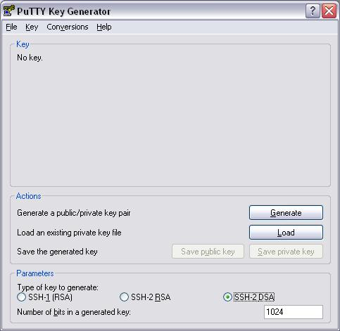
Generate your keys by moving your mouse over the blank area
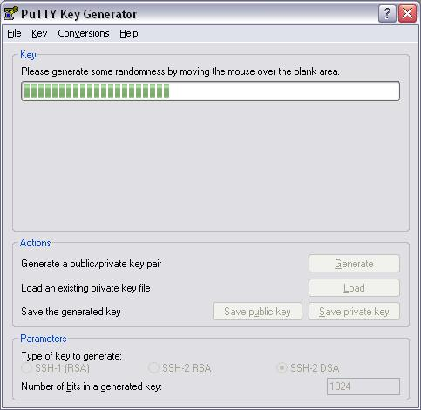
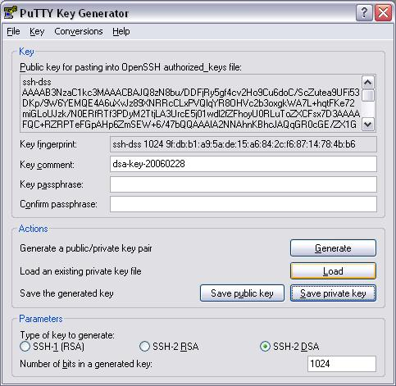

Copy your Public key for pasting into OpenSSH authorized_keys file:
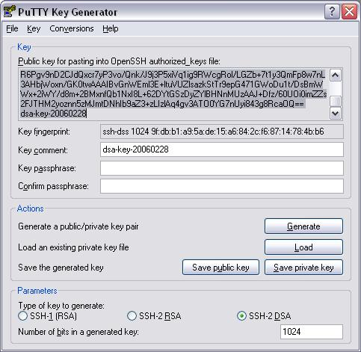

Copy the file on a directory reachable from the linux server you want to configure
- Paste this key in a text file (for example public_key.txt)
- Save your private key (please use the Save private key button and save this file with .ppk extension like “private_key.ppk”)

- Save your public key in a txt file in you samba shared user directory :
For the servers located in France :

\\frsplda01\users\<user name>
For the servers located in Montreal :
\\caribou\users\<user name>

Implement the key on the linux server

Make sure the file is available from the linux server:

ls -ld /users/<user name>/public_key.txt

If a authorized key arlready exists, back it up:
mv ~/.ssh/authorized_keys ~/.ssh/authorized_keys_bkp

Move the public key as authorized_keys under your home directory :
mv /users/<user name>/public_key.txt ~/.ssh/authorized_keys

Make sure the created file has the same rights and owner than the id_dsa.pub file:
ls -l ~/.ssh/authorized_keys ~/.ssh/id_dsa.pub

Setup the putty
Close your Linux session
Set up your putty with your private_key.ppk file and test your ssh connection
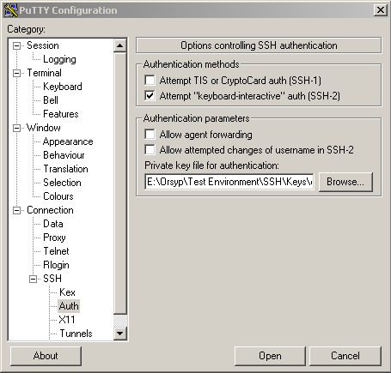

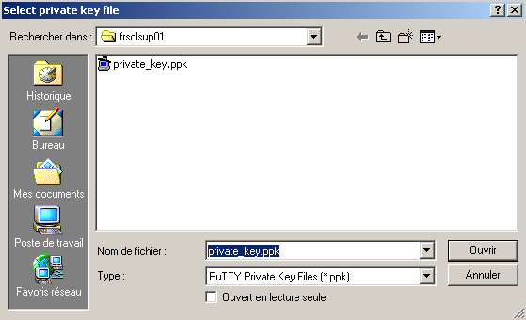

SSH2 set up between Linux and Linux without password

Find below an example to set up your ssh connection between frsdlsup02 and frsdlsup01:

First server (the one where ssh-keygen has been executed : frsdlsup01)
- Login on frsdlsup01
- Go to ~/.ssh directory
- add content of id_dsa.pub file at the end of the authorized file using the following command:
- cat id_dsa.pub >> authorized_keys

Save the id_dsa file on the shared directory :
cp ~/.ssh/id_dsa_pub /users/<user name>/

Second server : frsdlsup02
login on frsdlsup02
Go to ~/.ssh directory
get id_dsa file from the shared directory :
cp /users/<user name>/id_dsa_pub ~/.ssh/id_dsa_pub
update rights for this file
chmod 600 ~/.ssh/id_dsa
- try to connect on frsdlsup01 from frsdlsup02
- type
ssh frsdlsup01 and confirm your first connection by typing yes. This step is just needed for the first connection. It allows you to permanently add your host to the list of known hosts.
